Nepal College of Information Technology
Unit test I
Subject: Web Technology I

Program: BCA Full marks: 60 Pass Marks 30
Semester: V Time: 2 hrs

- Why TCP/IP is called a protocol suit? Describe the different layers of TCP/IP reference model in brief with a diagram showing the different layers. (10)

  - What do you mean by HTTP? What are the request headers, status codes, and message headers in HTTP? (5)
  - What is a URL? What are the different parts of a URL? Mention at least 4 protocols that can be used in the prefix of a URL. (5)

  - Describe the terms Web Servers and Web Browsers. What functional differences exist between them? (5)
  - What are markup languages? Describe in brief HTML and SGML. (5)

  - What are Physical and Logical Character formatting tags? Mention and write a line on at least three of each type. (5)
  - Write an HTML code to create a web page with following details: (5)
  - Background color: cyan
  - Title: “Web Programming Unit Test”
  - Main page heading with size H2 and aligned in the center: “A Test Page”.
  - A sub-heading aligned in the left with size H4 and underlined: “Introduction”
  - A paragraph of text with style Italic and aligned to the left of the page.

- Write HTML code to make a web page as shown. Title bar of the browser should display “Various text formats” (10)
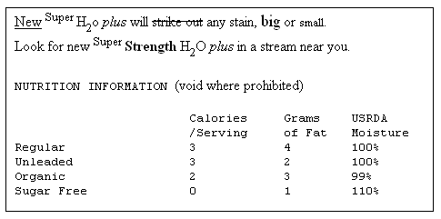
- Write short notes on (ANY TWO) (2*5)
  - FTP and TELNET
  - GIF and JPEG images
  - <IMG>, <BASEFONT>, <FONT> tags
  - <LINK>, <BASE> tags

